Low Stress Materials
ZL Quarterly
April 2010
As we all deal with a difficult and stressful economy, why should your material add to your stress? ZL’s extruded materials will help you take the stress out of stressful situations caused by materials filled with unnecessary stress. Stressful material can cause a variety of issues for you and your customers. For instance, material filled with stress can cause: excessive blade wear, loss of yield, cutting aggravation, unnecessarily tripping circuit breakers, and loss of time which takes away time from other important projects. These examples lead to the most important factor to avoid which is loss of profit. ZL’s low stress material will benefit your customers by giving you the ability to provide them with a lower stress material that will allow them to increase productivity by holding tighter tolerances, eliminating defective parts, and most importantly Lower Out The Door Cost!

Is Too Much Stress Stressing You Out?

New Addition to the ZL Team!!
ZL is pleased to announce
the addition of Tom Connelly in the role of sales and application development
specialist. With over 31 years’ experience
in the engineering plastics and plastic coatings markets, Tom brings
a unique skill set to ZL and its customers. Over the years, Tom has held positions in inside sales, field sales, tech service, application development, product management
and marketing, including several management positions in these areas. He
has worked for companies in the manufacturing,
distribution and fabrication segments of the engineering plastics industry. Based out of St. Louis, MO, Tom will have sales responsibility in the states of Missouri, Iowa, Minnesota, California, Oregon and Washington.
Tom will also travel extensively through the central and western U.S. working with OEMs and end users on application development, material
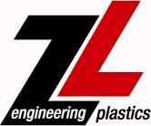
evaluations and product specifications.
8485 Artesia Blvd. Unit D· Buena Park, CA 90621· Phone: 714-523-0555· Fax: 714-523-4555
10902 Strang Line Rd· Lenexa, KS 66215· Phone: 913-327-0300· Fax: 913-327-0302

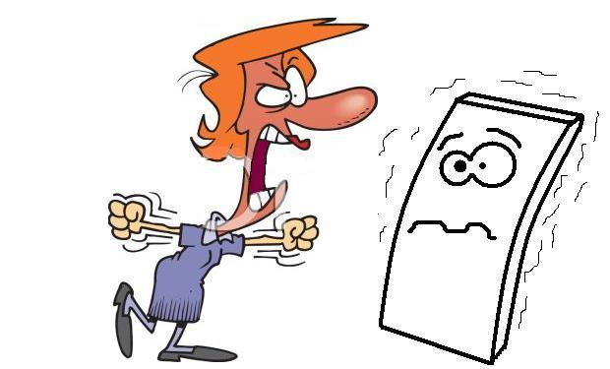

-Acetal sheet under unnecessary stress

